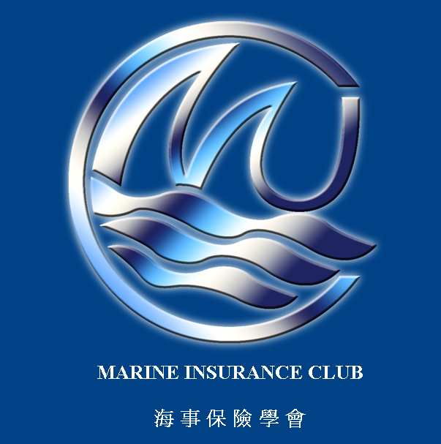 | MARINE INSURANCE CLUB LTD.  17/F, OTB Building, 160 Gloucester Road, Wanchai, Hong Kong
2018 SPRING LUNCH
REPLY FORM
PLEASE RELPY before close of business on 23 February 2018 (Friday)

To : Marine Insurance Club Ltd.
c/o Ms. Shirley Kwok or Mr. Ricky Tse
Email: shirley.kwok@axa-cs.com or tse@nordic-hamburg.com

Followed by post with payment to:
Ms. Lauder Shao
Marine Insurance Club, c/o Charles Taylor Adjusting
17/F, OTB Building, 160 Gloucester Road
Wanchai, Hong Kong.

(Your cheque should be made payable to “Marine Insurance Club Ltd.”

Name :

Company :

Tel : Email :

Signature: _______________________
Date: ___________________________

